Table of Contents

1. Introduction 2

2. Project Overview 2

2.1 Objective 2

2.2 Scope 2

3. Final Product 2

3.1 Link to Live Website 2

3.2 GitHub Repository 2

4. Technical Implementation 2

4.1 Project Structure 2

4.2 Pages Included & Code 3

Week 2 Page (week2.html) 4

Week 3 Page (week3.html) 5

Week 4 Page (week4.html) 6

Week 5 Page (week5.html) 7

4.3 Technologies Used 7

4.4 Responsive Design 8

4.4.1 Mobile-First Approach 8

10

4.5 JavaScript Interactivity 11

4.5.1 Features Implemented 11

5. Accessibility & Semantic HTML 11

5.1 WCAG 2.1 AA Compliance 11

6.Conclusion 11

7.1 AI Exchange 1 12

7.2 AI Exchange 2 16

7.3 AI Exchange 3 18

7.4 Full exchange 18

8.1 Reflection 18

# 1. Introduction

The creation of a personal portfolio website to highlight weekly web development work is presented in this paper. Leveraging HTML, CSS, and JavaScript, the project exhibits basic web design and development techniques. Reflecting both technical understanding and personal flair of the developer, the website was constructed with aesthetics, responsiveness, and accessibility in mind.

## 2. Project Overview

## 2.1 Objective

This project's primary goal is to create an accessible, professional, responsive portfolio website introducing the developer and showcasing weekly tasks produced over the semester.

## 2.2 Scope

* Create a multi-page static website using HTML, CSS, and JavaScript
* Include personal information, project summaries, and navigation
* Ensure responsive layout for mobile and desktop
* Apply accessibility best practices
* Host the website and provide version control via GitHub

# 3. Final Product

## 3.1 Link to Live Website

👉 <https://cerulean-mermaid-89f1ec.netlify.app>

## 3.2 GitHub Repository

🔗 <https://github.com/VeeneshwarenPerumal/wed-design-assignment-1>

# 4. Technical Implementation

## 4.1 Project Structure

portfolio/

├── index.html # Home page

├── week2.html # Basic Webpage Project

├── week3.html # Rock Paper Scissors Game

├── week4.html # RSS Reader

├── week5.html # Enhanced About Me

├── styles.css # Global stylesheet

└── images/ # Profile image

## 4.2 Pages Included & Code

**Home Page (index.html)**

*<!DOCTYPE html>*

*<html lang="en">*

*<head>*

*<meta charset="UTF-8">*

*<meta name="viewport" content="width=device-width, initial-scale=1.0">*

*<title>Portfolio - Home</title>*

*<link rel="stylesheet" href="styles.css">*

*</head>*

*<body>*

*<header>*

*<h1>Veeneshwaren Perumal</h1>*

*<nav>*

*<ul>*

*<li><a href="index.html">Home</a></li>*

*<li><a href="week2.html">Basic Webpage</a></li>*

*<li><a href="week3.html">Rock Paper Scissors</a></li>*

*<li><a href="week4.html">RSS Reader</a></li>*

*<li><a href="week5.html">Week 5</a></li>*

*</ul>*

*</nav>*

*</header>*

*<main>*

*<section>*

*<h2>Welcome to My Portfolio</h2>*

*<p>This website showcases my web development projects from the past weeks.</p>*

*</section>*

*<section>*

*<h2>About Me</h2>*

*<img src="images/profile.jpg" alt="Veeneshwaren Perumal" class="about-photo">*

*<p><strong>Veeneshwaren Perumal</strong> is a 24-year-old ambitious student pursuing <em>Business Information Systems</em> at Curtin University...</p>*

*</section>*

*</main>*

*</body>*

*</html>*

## Week 2 Page (week2.html)

*<!DOCTYPE html>*

*<html lang="en">*

*<head>*

*<meta charset="UTF-8">*

*<meta name="viewport" content="width=device-width, initial-scale=1.0">*

*<title>Week 2</title>*

*<link rel="stylesheet" href="styles.css">*

*</head>*

*<body>*

*<h1>Week 2 - Semantic HTML</h1>*

*<main>*

*<article>*

*<header><h2>My Semantic Page</h2></header>*

*<section>*

*<p>This is an example of semantic HTML including header, main, section, and article.</p>*

*</section>*

*<footer><p>&copy; 2025 Veeneshwaren Perumal</p></footer>*

*</article>*

*</main>*

*</body>*

*</html>*

## Week 3 Page (week3.html)

*<!DOCTYPE html>*

*<html lang="en">*

*<head>*

*<meta charset="UTF-8">*

*<meta name="viewport" content="width=device-width, initial-scale=1.0">*

*<title>Week 3 - Rock Paper Scissors</title>*

*<link rel="stylesheet" href="styles.css">*

*</head>*

*<body>*

*<h1>Rock Paper Scissors</h1>*

*<div>*

*<button onclick="play('rock')">Rock</button>*

*<button onclick="play('paper')">Paper</button>*

*<button onclick="play('scissors')">Scissors</button>*

*</div>*

*<p id="result"></p>*

*<script>*

*function play(player) {*

*const choices = ['rock', 'paper', 'scissors'];*

*const computer = choices[Math.floor(Math.random() * 3)];*

*let result = '';*

*if (player === computer) result = 'Draw!';*

*else if ((player === 'rock' && computer === 'scissors') || (player === 'scissors' && computer === 'paper') || (player === 'paper' && computer === 'rock')) result = 'You win!';*

*else result = 'You lose!';*

*document.getElementById('result').innerText = `Computer chose ${computer}. ${result}`;*

*}*

*</script>*

*</body>*

*</html>*

## Week 4 Page (week4.html)

*<!DOCTYPE html>*

*<html lang="en">*

*<head>*

*<meta charset="UTF-8">*

*<meta name="viewport" content="width=device-width, initial-scale=1.0">*

*<title>Week 4 - RSS Reader</title>*

*<link rel="stylesheet" href="styles.css">*

*</head>*

*<body>*

*<h1>RSS Feed Reader</h1>*

*<div id="feed"></div>*

*<script>*

*fetch('https://api.rss2json.com/v1/api.json?rss_url=https://rss.nytimes.com/services/xml/rss/nyt/HomePage.xml')*

*.then(response => response.json())*

*.then(data => {*

*const feed = document.getElementById('feed');*

*data.items.slice(0, 5).forEach(item => {*

*const article = document.createElement('div');*

*article.innerHTML = `<h3><a href="${item.link}">${item.title}</a></h3><p>${item.description}</p>`;*

*feed.appendChild(article);*

*});*

*});*

*</script>*

*</body>*

*</html>*

## Week 5 Page (week5.html)

*<!DOCTYPE html>*

*<html lang="en">*

*<head>*

*<meta charset="UTF-8">*

*<meta name="viewport" content="width=device-width, initial-scale=1.0">*

*<title>Week 5</title>*

*<link rel="stylesheet" href="styles.css">*

*</head>*

*<body>*

*<main>*

*<h1>Enhanced About Me</h1>*

*<section>*

*<img src="images/profile.jpg" alt="Veeneshwaren Perumal" class="about-photo">*

*<p>Hello! I'm Veeneshwaren, a passionate student from Mauritius who loves web development, cars, and anime...</p>*

*</section>*

*</main>*

*</body>*

*</html>*

## 4.3 Technologies Used

* **HTML5** – Structure and semantic content
* **CSS3** – Styling, layout, responsive design
* **JavaScript** – Dynamic interactivity (Week 3 & 4)
* **GitHub** – Version control and repository management
* **Google Fonts** – Custom typography

## 4.4 Responsive Design

## 4.4.1 Mobile-First Approach

The website was developed using a mobile-first approach with media queries to adapt layout for tablets and desktops. Navigation, text sizing, and images adjust based on screen width.

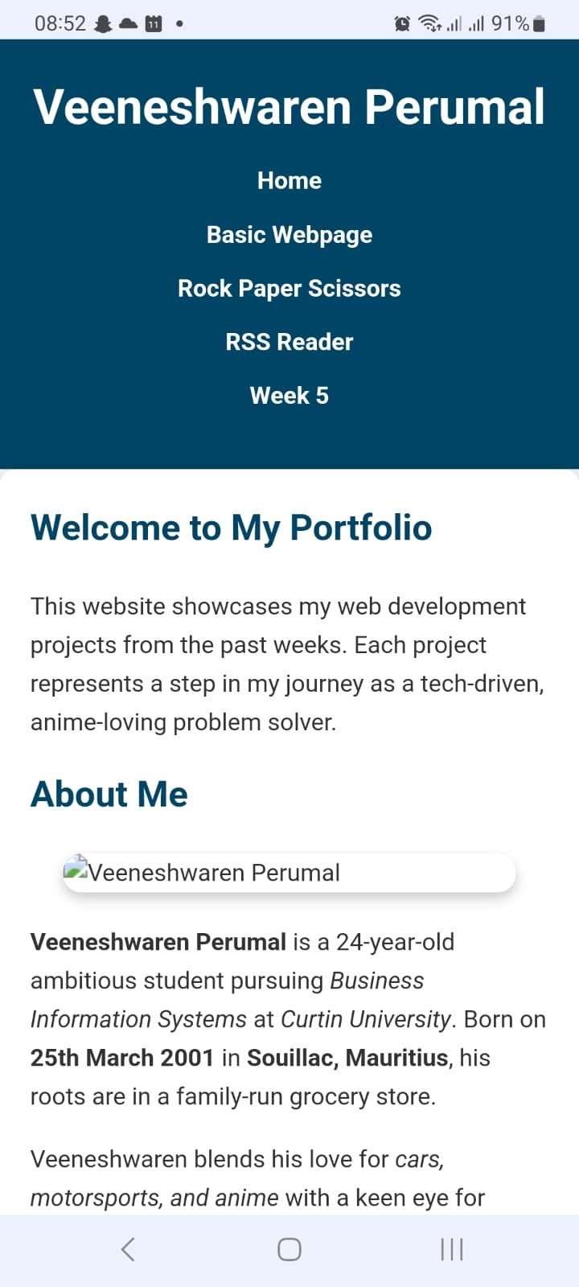

## 4.5 JavaScript Interactivity

## 4.5.1 Features Implemented

* **Rock Paper Scissors Game**: Uses random choices and dynamic UI updates
* **RSS Reader**: Fetches data from an RSS feed and displays it dynamically using fetch()

# 5. Accessibility & Semantic HTML

## 5.1 WCAG 2.1 AA Compliance

Accessibility principles followed:

* Semantic HTML (<main>, <section>, <header>, <nav>, <footer>)
* alt text for all images
* Keyboard navigation support
* Proper heading structure
* Good color contrast and font size responsiveness

6.Conclusion

This portfolio project deftly blends accessible best practices, coding knowledge, and artistic ability. The website follows web standards and responsive design while nevertheless capturing the developer's own style. It shows preparedness for industry-level front-end development and lays a good basis for next online projects.

.

# 7.1 AI Exchange 1

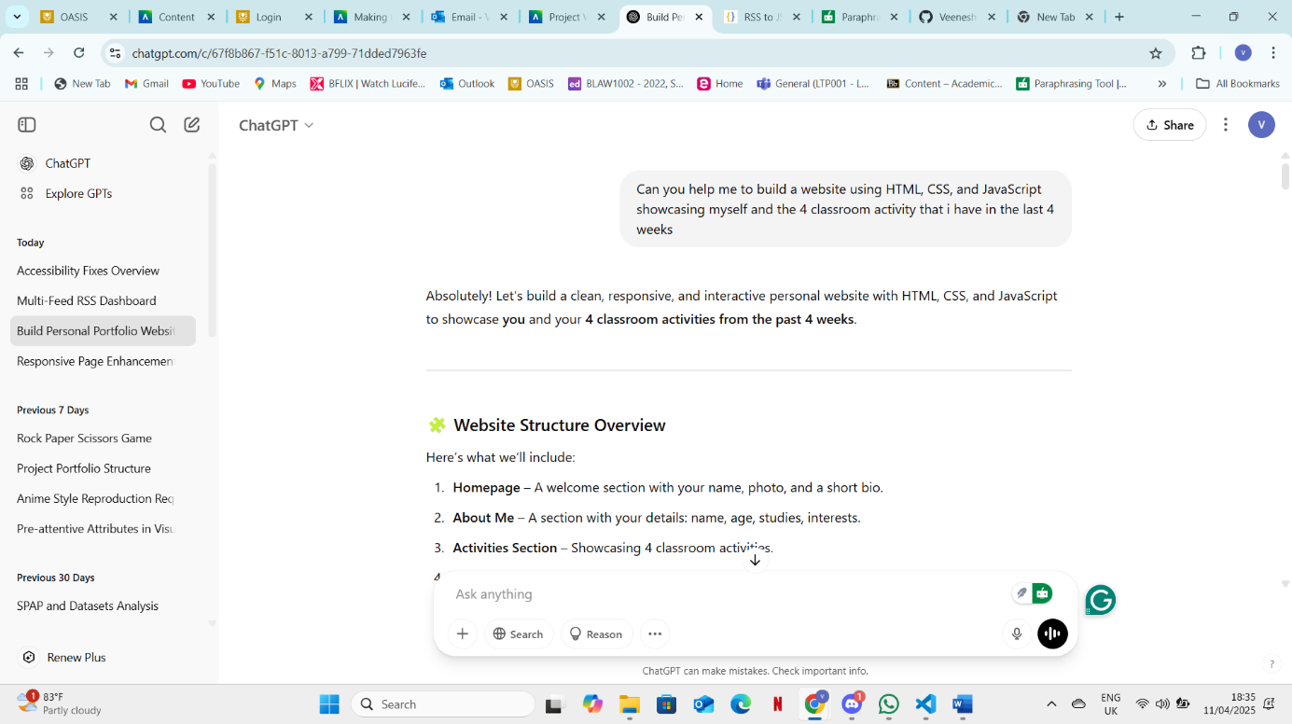

**Html**

*<!DOCTYPE html>*

*<html lang="en">*

*<head>*

*<meta charset="UTF-8" />*

*<meta name="viewport" content="width=device-width, initial-scale=1.0" />*

*<title>Veeneshwaren's Portfolio</title>*

*<link rel="stylesheet" href="style.css" />*

*</head>*

*<body>*

*<header>*

*<h1>Veeneshwaren Perumal</h1>*

*<nav>*

*<a href="#about">About Me</a>*

*<a href="#activities">Classroom Activities</a>*

*</nav>*

*</header>*

*<section id="hero">*

*<img src="your-photo.jpg" alt="Veeneshwaren" />*

*<h2>Hi, I'm Veeneshwaren!</h2>*

*<p>Passionate about Business Information Systems, cars, and technology.</p>*

*</section>*

*<section id="about">*

*<h2>About Me</h2>*

*<p><strong>Age:</strong> 24</p>*

*<p><strong>Studying:</strong> Business Information Systems (Curtin University)</p>*

*<p><strong>From:</strong> Souillac, Mauritius</p>*

*<p><strong>Hobbies:</strong> Cars, motorsports, anime</p>*

*</section>*

*<section id="activities">*

*<h2>Recent Classroom Activities</h2>*

*<div class="activity-cards">*

*<div class="card">*

*<h3>Week 1: Web Accessibility</h3>*

*<p>Improved HTML structure and used ARIA roles for better accessibility.</p>*

*</div>*

*<div class="card">*

*<h3>Week 2: Portfolio Site</h3>*

*<p>Started creating my personal portfolio using HTML, CSS, and JavaScript.</p>*

*</div>*

*<div class="card">*

*<h3>Week 3: JavaScript Interactivity</h3>*

*<p>Added DOM manipulation and user interactions to my site.</p>*

*</div>*

*<div class="card">*

*<h3>Week 4: Form Handling</h3>*

*<p>Learned to validate and handle user inputs using JavaScript.</p>*

*</div>*

*</div>*

*</section>*

*<footer>*

*<p>Contact: veeneshwaren@email.com</p>*

*<p>© 2025 Veeneshwaren Perumal</p>*

*</footer>*

*<script src="script.js"></script>*

*</body>*

*</html>*

**Style.css**

*body {*

*font-family: 'Segoe UI', sans-serif;*

*margin: 0;*

*padding: 0;*

*background: #f9f9f9;*

*color: #333;*

*}*

*header {*

*background: #2c3e50;*

*color: white;*

*padding: 1rem 2rem;*

*display: flex;*

*justify-content: space-between;*

*align-items: center;*

*}*

*nav a {*

*color: white;*

*margin-left: 1rem;*

*text-decoration: none;*

*}*

*#hero {*

*text-align: center;*

*padding: 2rem;*

*background: #ecf0f1;*

*}*

*#hero img {*

*width: 150px;*

*height: 150px;*

*border-radius: 50%;*

*}*

*section {*

*padding: 2rem;*

*}*

*.activity-cards {*

*display: grid;*

*grid-template-columns: repeat(auto-fit, minmax(220px, 1fr));*

*gap: 1rem;*

*}*

*.card {*

*background: white;*

*padding: 1rem;*

*border-radius: 10px;*

*box-shadow: 0 2px 5px rgba(0,0,0,0.1);*

*}*

*footer {*

*text-align: center;*

*padding: 1rem;*

*background: #2c3e50;*

*color: white;*

*}*

# 7.2 AI Exchange 2

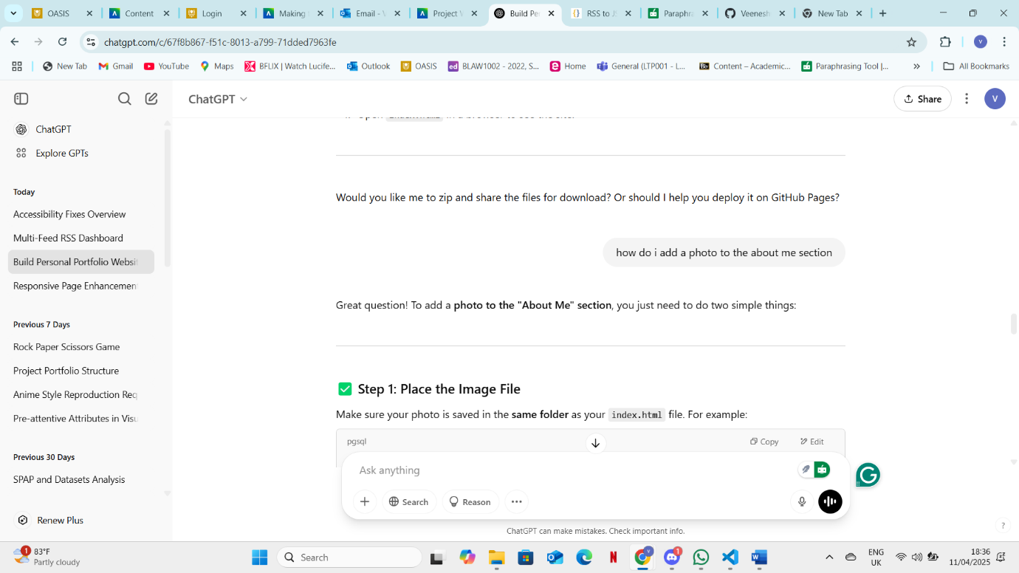

**Html**

*<section id="about">*

*<h2>About Me</h2>*

*<img src="veenesh.jpg" alt="Veeneshwaren Perumal" class="about-photo" />*

*<p><strong>Age:</strong> 24</p>*

*<p><strong>Studying:</strong> Business Information Systems (Curtin University)</p>*

*<p><strong>From:</strong> Souillac, Mauritius</p>*

*<p><strong>Hobbies:</strong> Cars, motorsports, anime</p>*

*</section>*

**Style.css**

*.about-photo {*

*width: 200px;*

*height: auto;*

*border-radius: 15px;*

*display: block;*

*margin: 1rem auto;*

*box-shadow: 0 4px 10px rgba(0,0,0,0.2);*

*}*

# 7.3 AI Exchange 3

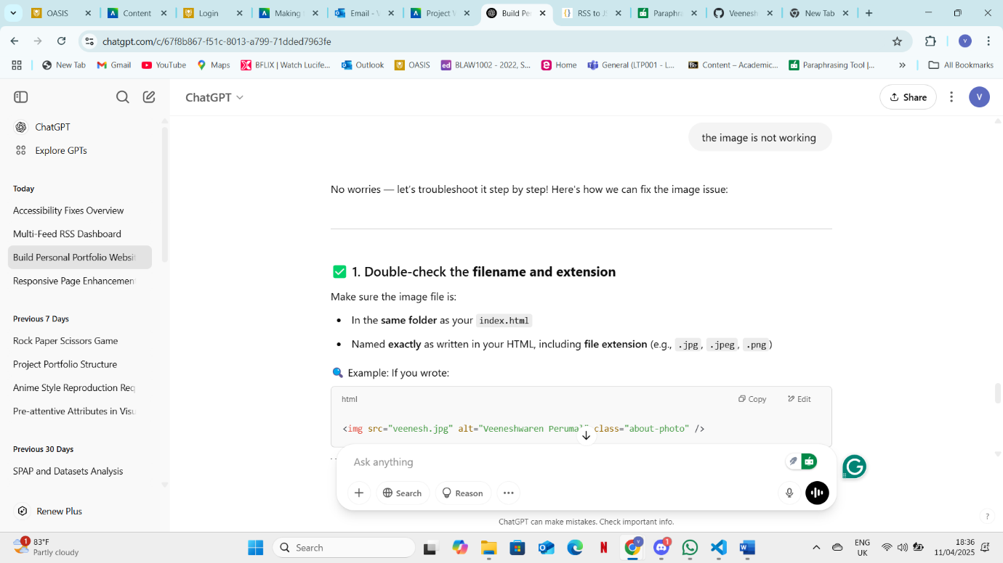

## 7.4 Full exchange

<https://chatgpt.com/share/67f92c7d-6990-8013-9161-55f036130339>

# 8.1 Reflection

Creating my own portfolio website was a fascinating and instructive process. Developing a platform that not only highlighted my weekly work but also represented my own style, hobbies, and development as a web developer. To guarantee the site was responsive across all devices, I selected a neat, ordered layout and used a mobile-first design philosophy. For improved SEO and accessibility, I employed semantic HTML elements; CSS gave a contemporary and aesthetically pleasing user experience.  
  
Including JavaScript capabilities proved to be one of my toughest tasks, particularly for the RSS Reader and the Rock Paper Scissors game. Debugging logical mistakes and creating a dynamic interface needed time and repeated testing. For the RSS Reader, for instance, I had to make sure material loaded in a user-friendly way and gracefully manage fetch mistakes.  
  
One big help for me in my development process was working with artificial intelligence, especially ChatGPT. It provided clear code samples, helped to define ideas, and was always a friend in need of problems solved. It improved rather than replaced my thinking; it guided me when I was stuck and taught me fresh approaches and better coding techniques.  
  
Regarding non-compliance, originally my colour contrast was compliant and several photographs missing alt attributes. Lighthouse helped to identify these problems and guide their resolution. This let me realise from the beginning of a project the significance of accessibility.  
  
This experience has generally increased my confidence in front-end programming and sharpened my knowledge of best practices in responsive and accessible web design.